***Test Data Table***

|  |  |  |  |  |
| --- | --- | --- | --- | --- |
| ***Test data type*** | ***Test***  ***Data*** | ***The reason it was selected*** | ***The output expected due to the use of the test data*** | ***The screenshot of actual output when the test data is used*** |
| ***Normal*** | Height of tree = 40  Width of tree =20  Height of tree stem = 40  Width of tree stem = 5 | *This data is selected because to check that if we disturb the data of the tree creation that can affect the logic and the creation of gui or not* | The size of tree become small as compared to the pervious size of tree | ***Picture No: 1*** |
| ***Normal*** | Mouse Click at the pixels:  -382.0 -44.0  -381.0 31.0  -388.0 92.0  -322.0 320.0  -322.0 320.0 | *To test the Mouse functionality that does it works outside the rectangle or not* | *The Mouse does not work outside the rectangle* | ***Picture No: 2*** |
| ***Abnormal*** | Width of tree = 40  Height of tree = 10 | *This data is selected because to check that if we disturb the data of the tree creation that can affect the logic and the creation of gui or not* | The shape of the tree is constructed and un useful shape is made which doesn’t having any mean | ***Picture No: 3*** |
| ***Abnormal*** | Movement of Bird = 0  Toward left and right | This data is selected because to check that an error is generated or not | Excepted that an error is generated of no movement | ***Picture No: 4*** |

|  |  |  |  |  |
| --- | --- | --- | --- | --- |
| ***Normal*** | Movement of Bird = 8  Toward left and right | This data is selected because check how much the movement is decreases | Movement Is decreases by some degree | ***Picture No: 5*** |
| ***Abnormal*** | Width of tree = 40  Height of tree = 10  Height_stem = 3  Width_stem = 1 | *This data is selected because to check that if we disturb the data of the tree creation that can affect the logic and the creation of gui or not* | If there is no shape of tree is generated then some kind of message is generated | ***Picture No: 6*** |

***Picture No: 1***

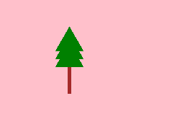

***Picture No: 2***

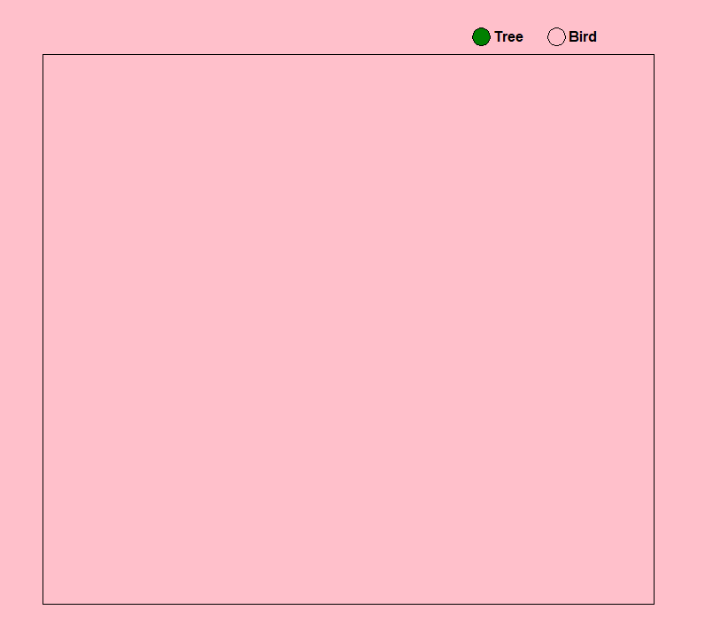

***Picture No: 3***

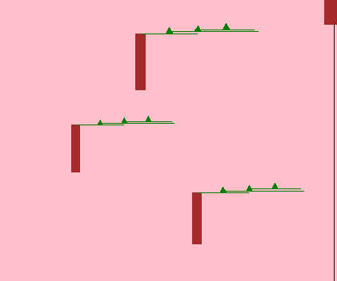

***Picture No: 4***

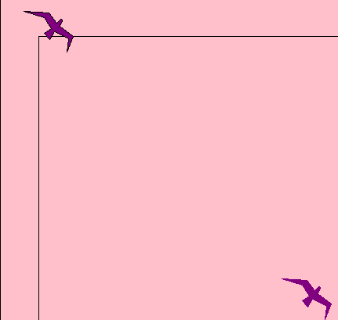

***Picture No: 5***

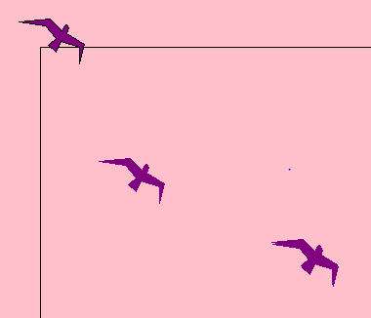

***Picture No: 6***

